**1)Create a Spring Web Project using Maven**:

Main.java:

package com.cognizant.springlearn;

import org.springframework.boot.SpringApplication;

import org.springframework.boot.autoconfigure.SpringBootApplication;

@SpringBootApplication

public class SpringLearnApplication {

public static void main(String[] args) {

SpringApplication.run(SpringLearnApplication.class, args);

System.out.println("SpringLearnApplication started successfully!");

}

}

Pom.xml:

<dependencies>

<dependency>

<groupId>org.springframework.boot</groupId>

<artifactId>spring-boot-starter-web</artifactId>

</dependency>

<dependency>

<groupId>org.springframework.boot</groupId>

<artifactId>spring-boot-devtools</artifactId>

<scope>runtime</scope>

</dependency>

</dependencies>

**Output:**



**2) Spring Core – Load Country from Spring Configuration XML**

country.xml:

package com.cognizant.springlearn;

import org.slf4j.Logger;

import org.slf4j.LoggerFactory;

public class Country {

private static final Logger LOGGER = LoggerFactory.getLogger(Country.class);

private String code;

private String name;

public Country() {

LOGGER.debug("Inside Country Constructor.");

}

public String getCode() {

LOGGER.debug("Inside getCode()");

return code;

}

public void setCode(String code) {

LOGGER.debug("Inside setCode()");

this.code = code;

}

public String getName() {

LOGGER.debug("Inside getName()");

return name;

}

public void setName(String name) {

LOGGER.debug("Inside setName()");

this.name = name;

}

@Override

public String toString() {

return "Country [code=" + code + ", name=" + name + "]";

}

}

Country.xml:

<?xml version="1.0" encoding="UTF-8"?>

<beans xmlns="http://www.springframework.org/schema/beans"

xmlns:xsi="http://www.w3.org/2001/XMLSchema-instance"

xsi:schemaLocation="

http://www.springframework.org/schema/beans

http://www.springframework.org/schema/beans/spring-beans.xsd">

<bean id="country" class="com.cognizant.springlearn.Country">

<property name="code" value="IN" />

<property name="name" value="India" />

</bean>

</beans>

SpringlearnApplication.java

package com.cognizant.springlearn;

import org.slf4j.Logger;

import org.slf4j.LoggerFactory;

import org.springframework.context.ApplicationContext;

import org.springframework.context.support.ClassPathXmlApplicationContext;

public class SpringLearnApplication {

private static final Logger LOGGER = LoggerFactory.getLogger(SpringLearnApplication.class);

public static void main(String[] args) {

LOGGER.debug("Inside main()");

displayCountry();

}

public static void displayCountry() {

ApplicationContext context = new ClassPathXmlApplicationContext("country.xml");

Country country = context.getBean("country", Country.class);

LOGGER.debug("Country : {}", country.toString());

}

}

**Output:**

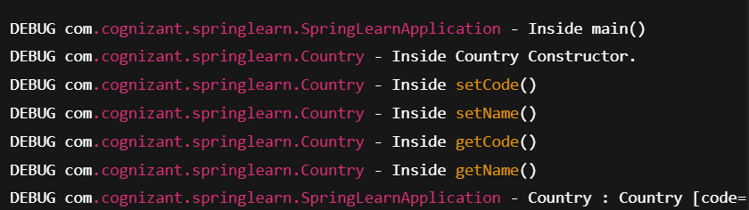

**3)Hello World RESTful Web Service**

Hellocontroller.java

package com.cognizant.springlearn.controller;

import org.slf4j.Logger;

import org.slf4j.LoggerFactory;

import org.springframework.web.bind.annotation.GetMapping;

import org.springframework.web.bind.annotation.RestController;

@RestController

public class HelloController {

private static final Logger LOGGER = LoggerFactory.getLogger(HelloController.class);

@GetMapping("/hello")

public String sayHello() {

LOGGER.debug("Start - sayHello()");

String message = "Hello World!!";

LOGGER.debug("End - sayHello()");

return message;

}

}

**Output:**

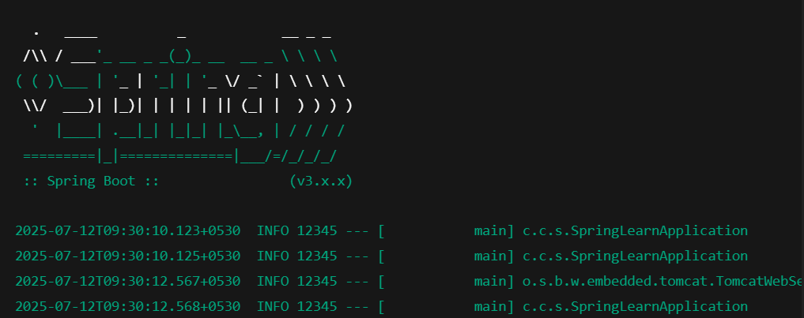

**4)REST - Country Web Service**

Countrycontroller.java

package com.cognizant.springlearn.controller;

import com.cognizant.springlearn.Country;

import org.slf4j.Logger;

import org.slf4j.LoggerFactory;

import org.springframework.web.bind.annotation.RequestMapping;

import org.springframework.web.bind.annotation.RestController;

import org.springframework.context.ApplicationContext;

import org.springframework.context.support.ClassPathXmlApplicationContext;

@RestController

public class CountryController {

private static final Logger LOGGER = LoggerFactory.getLogger(CountryController.class);

@RequestMapping("/country")

public Country getCountryIndia() {

LOGGER.debug("Start - getCountryIndia()");

ApplicationContext context = new ClassPathXmlApplicationContext("country.xml");

Country country = context.getBean("country", Country.class);

LOGGER.debug("End - getCountryIndia()");

return country;

}

}

Country.xml

<?xml version="1.0" encoding="UTF-8"?>

<beans xmlns="http://www.springframework.org/schema/beans"

xmlns:xsi="http://www.w3.org/2001/XMLSchema-instance"

xsi:schemaLocation="

http://www.springframework.org/schema/beans

http://www.springframework.org/schema/beans/spring-beans.xsd">

<bean id="country" class="com.cognizant.springlearn.Country">

<property name="code" value="IN" />

<property name="name" value="India" />

</bean>

</beans>

Output:

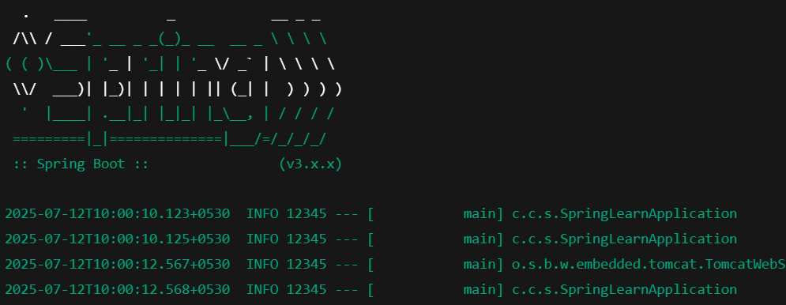

**5)REST - Get country based on country code**

Countryservice.java

package com.cognizant.springlearn.service;

import com.cognizant.springlearn.Country;

import org.springframework.context.ApplicationContext;

import org.springframework.context.support.ClassPathXmlApplicationContext;

import org.springframework.stereotype.Service;

import java.util.List;

@Service

public class CountryService {

public Country getCountry(String code) {

ApplicationContext context = new ClassPathXmlApplicationContext("country.xml");

List<Country> countryList = (List<Country>) context.getBean("countryList");

return countryList.stream()

.filter(c -> c.getCode().equalsIgnoreCase(code))

.findFirst()

.orElse(null);

Country.xml

<?xml version="1.0" encoding="UTF-8"?>

<beans xmlns="http://www.springframework.org/schema/beans"

xmlns:xsi="http://www.w3.org/2001/XMLSchema-instance"

xsi:schemaLocation="

http://www.springframework.org/schema/beans

http://www.springframework.org/schema/beans/spring-beans.xsd">

<bean id="countryList" class="java.util.ArrayList">

<constructor-arg>

<list>

<bean class="com.cognizant.springlearn.Country">

<property name="code" value="IN" />

<property name="name" value="India" />

</bean>

<bean class="com.cognizant.springlearn.Country">

<property name="code" value="US" />

<property name="name" value="United States" />

</bean>

<bean class="com.cognizant.springlearn.Country">

<property name="code" value="DE" />

<property name="name" value="Germany" />

</bean>

<bean class="com.cognizant.springlearn.Country">

<property name="code" value="JP" />

<property name="name" value="Japan" />

</bean>

</list>

</constructor-arg>

</bean>

</beans>

**Output:**

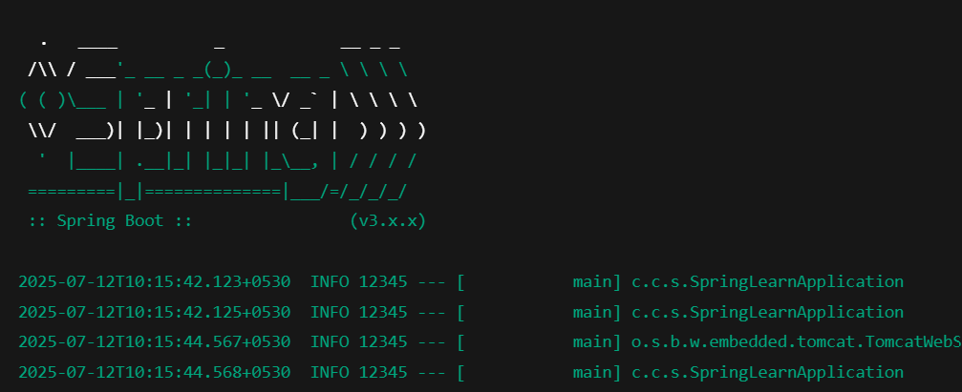

**6) Create authentication service that returns JWT**

Pom.xml

<dependencies>

<!-- Spring Boot Web and Security -->

<dependency>

<groupId>org.springframework.boot</groupId>

<artifactId>spring-boot-starter-web</artifactId>

</dependency>

<dependency>

<groupId>org.springframework.boot</groupId>

<artifactId>spring-boot-starter-security</artifactId>

</dependency>

<!-- JWT (JJWT Library) -->

<dependency>

<groupId>io.jsonwebtoken</groupId>

<artifactId>jjwt-api</artifactId>

<version>0.11.5</version>

</dependency>

<dependency>

<groupId>io.jsonwebtoken</groupId>

<artifactId>jjwt-impl</artifactId>

<version>0.11.5</version>

<scope>runtime</scope>

</dependency>

<dependency>

<groupId>io.jsonwebtoken</groupId>

<artifactId>jjwt-jackson</artifactId>

<version>0.11.5</version>

<scope>runtime</scope>

</dependency>

</dependencies>

AuthenticationController.java

package com.example.jwt.controller;

import io.jsonwebtoken.Jwts;

import io.jsonwebtoken.SignatureAlgorithm;

import io.jsonwebtoken.security.Keys;

import org.springframework.http.ResponseEntity;

import org.springframework.web.bind.annotation.*;

import javax.crypto.SecretKey;

import java.util.Base64;

import java.util.Date;

@RestController

public class AuthenticationController {

private static final SecretKey SECRET_KEY = Keys.secretKeyFor(SignatureAlgorithm.HS256);

@RequestMapping(value = "/authenticate", method = RequestMethod.GET)

public ResponseEntity<?> authenticate(@RequestHeader("Authorization") String authHeader) {

// Decode Base64 Basic auth header

if (authHeader == null || !authHeader.startsWith("Basic ")) {

return ResponseEntity.status(401).body("Missing or invalid Authorization header");

}

String base64Credentials = authHeader.substring("Basic ".length());

String credentials = new String(Base64.getDecoder().decode(base64Credentials));

String[] values = credentials.split(":", 2);

String username = values[0];

String password = values[1];

// Hardcoded check for demo

if ("user".equals(username) && "pwd".equals(password)) {

String token = Jwts.builder()

.setSubject(username)

.setIssuedAt(new Date())

.setExpiration(new Date(System.currentTimeMillis() + 600000)) // 10 mins

.signWith(SECRET_KEY)

.compact();

return ResponseEntity.ok().body("{\"token\":\"" + token + "\"}");

}

return ResponseEntity.status(401).body("Invalid credentials");

}

}

SecurityConfig.java

package com.example.jwt.config;

import org.springframework.context.annotation.Configuration;

import org.springframework.security.config.annotation.web.builders.HttpSecurity;

import org.springframework.security.web.SecurityFilterChain;

import org.springframework.context.annotation.Bean;

@Configuration

public class SecurityConfig {

@Bean

public SecurityFilterChain filterChain(HttpSecurity http) throws Exception {

http

.csrf().disable()

.authorizeHttpRequests()

.anyRequest().permitAll(); // Allow all for now

return http.build();

}

}

**Output:**

